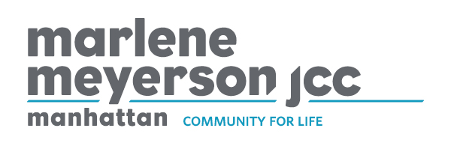
Department: Information Technology
JOB TITLE: Help Desk Technician
Reports To: Network Systems Administrator
FLSA Status: Non-Exempt
DATE: June 2021

Description
The Help Desk Specialist’s role is to provide excellent customer service and technical support to 300 end users. The Help Desk Specialist provides support and maintenance of the organization’s desktop computing environment. This position assists the Network Systems Administrator and contractors in the management and administration of the organization's local area network, servers, internet connectivity and voice and data systems. This includes responding to user questions and requests and installing, diagnosing, repairing, maintaining, and upgrading all PC and Mac hardware, desktop software and equipment to ensure optimal workstation performance. This position will also troubleshoot problem areas in person, by telephone, email or via remote desktop in a timely and accurate fashion, and provide end-user assistance where required. This position is responsible for maintaining the ticketing system and documenting all requests and actions related to technology services. We are committed to exceptional customer service. The Help Desk Specialist will need to provide timelines and accurate, courteous and professional support to all users.

Responsibilities
Desktop, Application and Software Support
- Provide end-users with on-site and remote support for installation, configuration and problem resolution, on desktops, laptops, mobile devices, desk phones, and printers.
- Monitor, troubleshoot, and resolve all operational and software problems associated with computers, network and stand-alone printers and document all requests via the ticketing system
- Prepare new equipment for users including hardware, software, phone and network connectivity.
- Diagnose and resolve problems, maintain equipment and provide Windows 7,8, 10 and Mac desktop support.
- Assist in employee onboarding and terminating process.
- Assist with server and desktop patching and maintenance.
- Maintain hardware and software license inventory using shared google doc
- Help in maintenance and expansion of data and voice cabling infrastructure.
- Setup and provide support of Google Apps, e-mail, documents, groups and calendar accounts via google admin console.
- Lead or participate in technology projects and accomplish other tasks and functions as assigned.
- Help Network Systems Administrator in the management of the phone and voicemail system
  - Telephone adds, moves and changes.
  - Phone number, extension and voice mailbox assignment
  - Call Attendant Administration.

Position Requirements
Education & Certification
- College degree in the field of computer science and/or equivalent work experience.
- Technical certifications a plus

Knowledge & Experience
- Help Desk: 2 years (Required)
- Working knowledge of Windows Active Directory
- Working knowledge of Windows DHCP, DNS and LAN Topologies
- Excellent technical knowledge of PC and Mac desktop hardware.
- Hands-on hardware troubleshooting experience.
- Working technical knowledge of Microsoft operating systems.
- Able to read and understand technical manuals and procedural documentation.

Personal Attributes
- Strong customer-service orientation.
- Self-motivated with the ability to effectively prioritize and execute tasks in a high-pressure environment.
- Experience working in a team-oriented, collaborative environment.
- Effective interpersonal skills and relationship-building skills.
- Strong written and oral communication skills.
- Analytical and problem-solving abilities, with keen attention to detail.

Work Conditions.
- Lifting and transporting of heavy to moderately heavy objects, such as computers and peripherals.
- Availability to work weekends as needed as well as off hours during registration and maintenance periods. Working on New Year’s Day is required.

To apply, please send cover letter including requirements and resume to nidowu@mmjccm.org

Salary range: $50,000 - $56,000

Diversity is a core value of the Marlene Meyerson JCC Manhattan. We believe the power of diversity enriches all of us by exposing us to a range of ways to understand and engage with the world, identify challenges, and to discover, design and deliver solutions.

