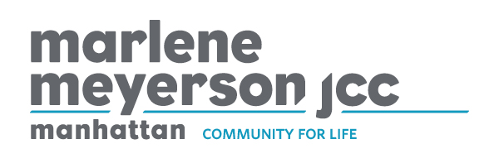
JOB TITLE: Facilitators for Special Needs Programs – Part Time
REPORTS TO: Center Director
FLSA STATUS: Non-exempt
DATE: June 2021
The Center for Special Needs (CSN) is looking for an engaging and enthusiastic person or people to work part time within some of our program areas and/or with individual participants. Connections and Adaptations are social and recreational programs designed to serve young adults with a range of abilities. Through exciting and engaging activities such as art classes, fitness and virtual travel, participants have a ton of fun while connecting with peers and building relationships in a supportive environment.

Staff role could include facilitating small group activities and discussions, providing activity instruction to a larger group and working individually with participants both within programming and out in the community. Programming is primarily virtual at this time, though there are some in person opportunities available. Number of hours and schedule tbd based on availability and alignment with program hours.

$20-$25/hr
TO APPLY:
Please send cover letter including salary requirements and resume to recruitment@mmjccm.org.
Diversity is a core value of The Marlene Meyerson JCC Manhattan. We believe the power of diversity enriches all of us by exposing us to a range of ways to understand and engage with the world, identify challenges, and to discover, design and deliver solutions.

